Please fill in, scan (or photograph) this form and email to hannah.persaud@nhs.net by Tuesday 20th November at the latest. Unfortunately applications received after this date will not be considered.

Application for Virgin Money London Marathon Place

Sunday 28th April, 2019

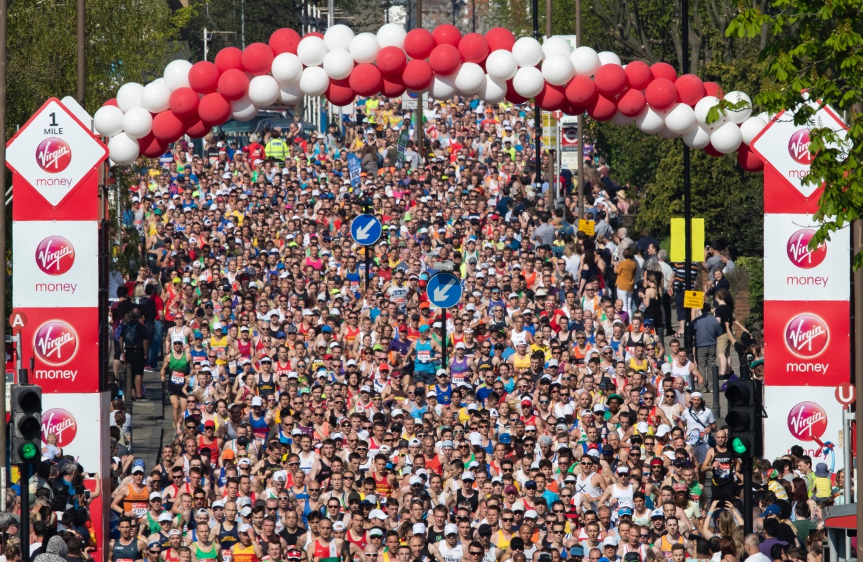
Thank you so much for your interest in running the Virgin Money London Marathon 2019 in support of UCL Hospitals Charitable Foundation.

We have one place to allocate to one outstanding fundraiser for this iconic run. If you are successful in securing the place we will ask you to pay a £200 non-refundable registration fee and raise a minimum of £2,500 (please note that the £200 registration fee will count towards your fundraising total) to help us continue supporting UCLH NHS Foundation Trust, delivering cutting edge research and first-class patient care. Please answer all sections in this application form carefully, paying special attention to how you would plan to reach this fundraising target.

If you have any questions please contact hannah.persaud@nhs.net

Your details
Title

First Name

Last Name

Date of Birth

Email Address

Home Number

Mobile Number

Occupation

Employers Name

Where did you hear about UCL Hospitals Charitable Foundation London Marathon place? (please tick the one that applies)

UCL Hospitals Charitable Foundation newsletter
UCL Hospitals Charitable Foundation website
Twitter

The London Marathon website

Other

What previous running experience do you have?

Did you also enter the Virgin Money London Marathon ballot?

How would you plan to raise the minimum sponsorship target? Please give as much detail as possible.

Please explain why you would like to take part in an event for UCL Hospitals Charitable Foundation eg. you have a personal connection to our organisation, or know one of our projects, or you work for UCLH NHS Foundation Trust, etc

If you are employed, does your employer offer matched funding?

Yes
No
Not sure

Have you raised money and/or taken part in any of our other events before?

Yes
Not Yet

Terms and Conditions

- UCL Hospitals Charitable Foundation does not take responsibility for any health issues during your training for the London Marathon or any incidents that occur on race day. If you have any health concerns prior to, or during your training, please consult with your doctor.
- UCL Hospitals Charitable Foundation reserves the right to refuse an application at its absolute discretion with no explanation.
- You must be 18 years or over on the day of the race.
- If you are unable to participate in the event for any reason, all donated monies collected in support of UCL Hospitals Charitable Foundation must be forwarded to the charity or returned to the individual sponsors (if they so request). Monies already received by the charity will not be refunded.
- You must contact UCL Hospitals Charitable Foundation immediately if you think you’re going to be unable to participate.
- When UCL Hospitals Charitable Foundation establishes contact described as “urgent”, runners must respond via email/telephone as quickly as possible.
- By signing up to the London Marathon you are consenting to UCL Hospitals Charitable Foundation using any images of you in their promotional materials. Please contact us in advance of the London Marathon if you are unhappy with this arrangement.

By registering for this event you are agreeing to receive email, phone, text and/or postal communications from us in relation to your participation in the event.

Please see our Privacy Policy on our website for details about how we will use your personal information and keep it safe and secure.

Declaration

I confirm that if offered UCL Hospitals Charitable Foundation guaranteed entry place I am happy to pay a non-refundable registration fee of £200 and commit to doing so within three working days of notification of the place.

Yes
No

I have read and understood the terms and conditions above and I understand that if accepted for the UCL Hospitals Charitable Foundation charity place, I am undertaking a pledge to raise £2,500 (excluding gift aid) and the money will be paid to UCL Hospitals Charitable Foundation no later than 28th May 2019.

Yes
No

Print Name___________________ Signature_________________Date_________________

Please note that this application form must be received by Hannah Persaud no later than Tuesday 20th November. Application forms received after this date will not be considered. Please fill in, scan (or photograph) and return this form to hannah.persaud@nhs.net

